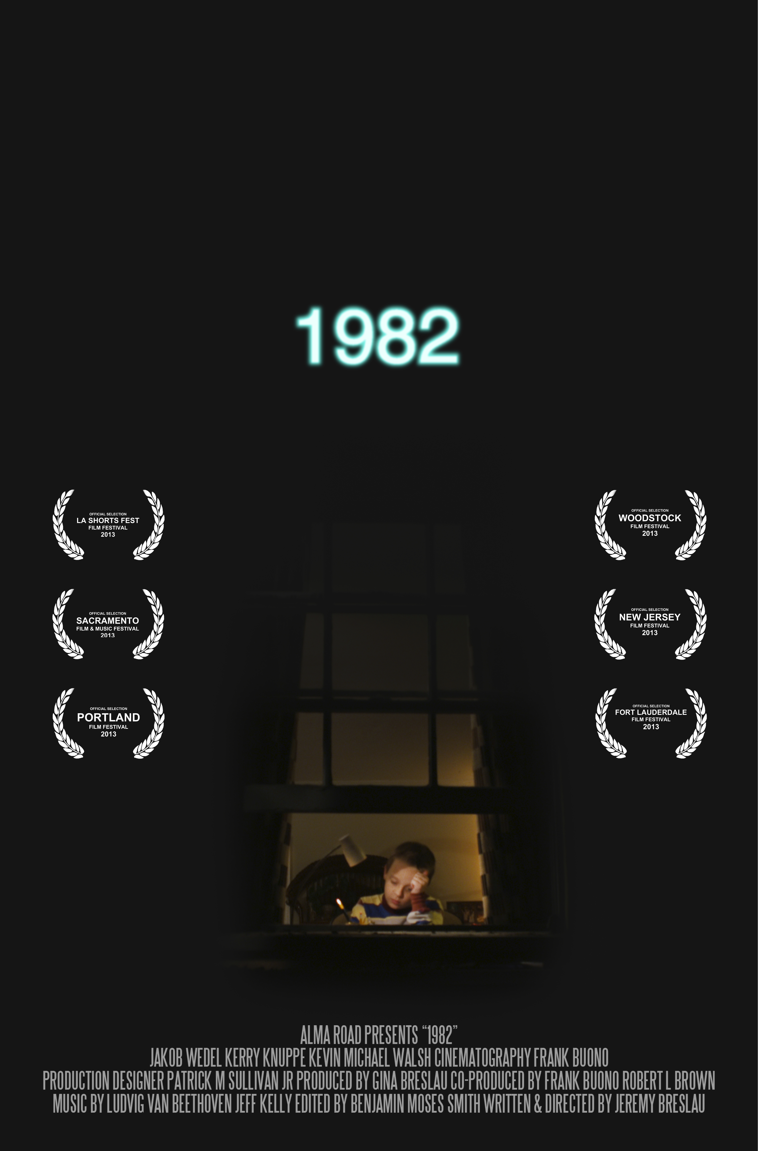

ALMA ROAD AND A. BUONO PRODUCTION TAKE
AN EMOTIONAL JOURNEY BACK TO
1982

A LYRICAL PORTRAIT OF A TROUBLED CHILDHOOD FROM WRITER/DIRECTOR JEREMY BRESLAU

Writer/Director: The short film is written and directed by Jeremy Breslau.

Production Companies: Alma Road and A. Buono Production

Producer: Gina Breslau

Co-Producers: Frank Buono and Robert L. Brown

Logline: A blocked novelist reflects on a pivotal year in his life, when, as a precocious six-year-old, he struggled for the attention of his bickering parents.

Synopsis: Frustrated by his young son's interruptions as he writes in bed on a stormy evening, a stifled horror novelist finds himself contemplating the year in his life when his own anxieties began. What follows is an impressionistic journey into his past, where he re-imagines the emotional events that ended his childhood in one seamless memory that transitions from morning to night and across the seasons.

Utilizing the talents of veteran art director Patrick M. Sullivan Jr. (part of the Oscar-winning team behind Memoirs of a Geisha) and Cinematographer Frank Buono (whose work includes one of AMC’s best tracking shots of all time for Children of Men), in conjunction with the practical magic of the Chiodo Bros (Team America) and Gradient Effects, responsible for much of the technical wizardy in The Harry Potter franchise, 1982 employs one-of-a-kind custom rigs, in conjunction with miniatures and the latest digital technology to create the feeling of a memory in one lyrical, unbroken shot.

Director’s Statement: “I wanted to explore the transitional period in childhood when we begin to realize that our world is a lot less secure than we thought it was. I was also interested in how strong childhood memories can unexpectedly bubble to the surface and influence our choices as adults.”

THE TEAM
JEREMY BRESLAU Writer/Director
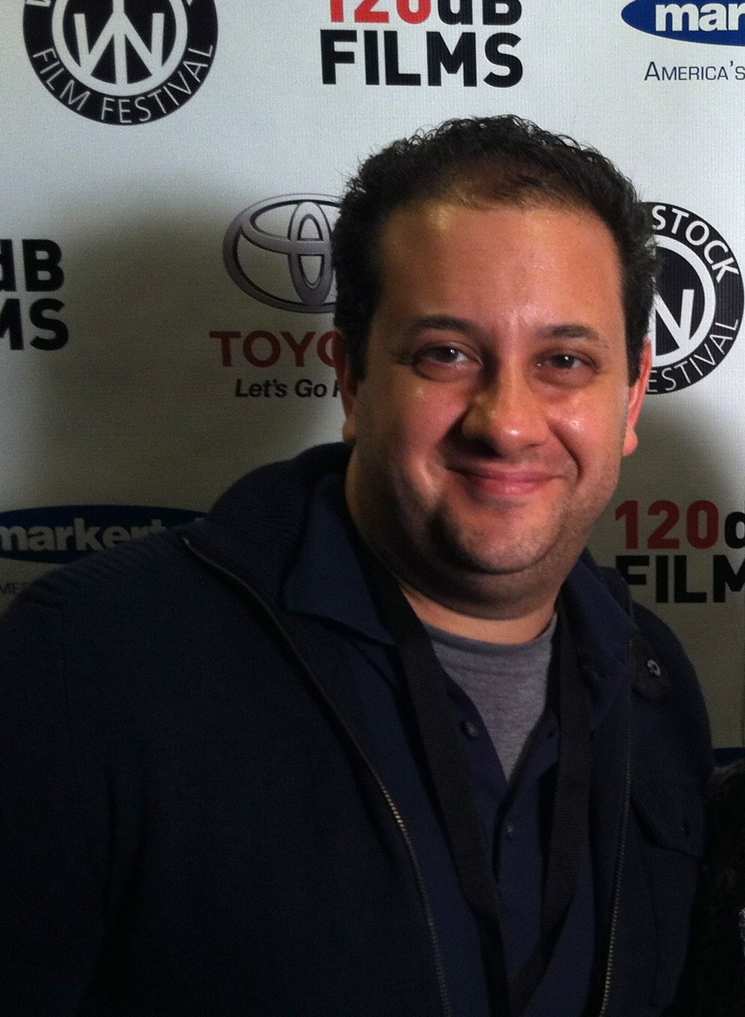

Jeremy earned his MFA in screenwriting from USC. While there, in addition to writing and directing award-winning shorts, his screenplay, Plague Season, was a semi-finalist in the Nicholl Competition. Based on his Nicholl script, Fox Searchlight signed Jeremy to a first-look deal and produced his next short, after which he created a successful web series for MTV’s AtomFilms. Currently, Jeremy is developing two features that will utilize the talents of the team behind 1982.

GINA BRESLAU Producer
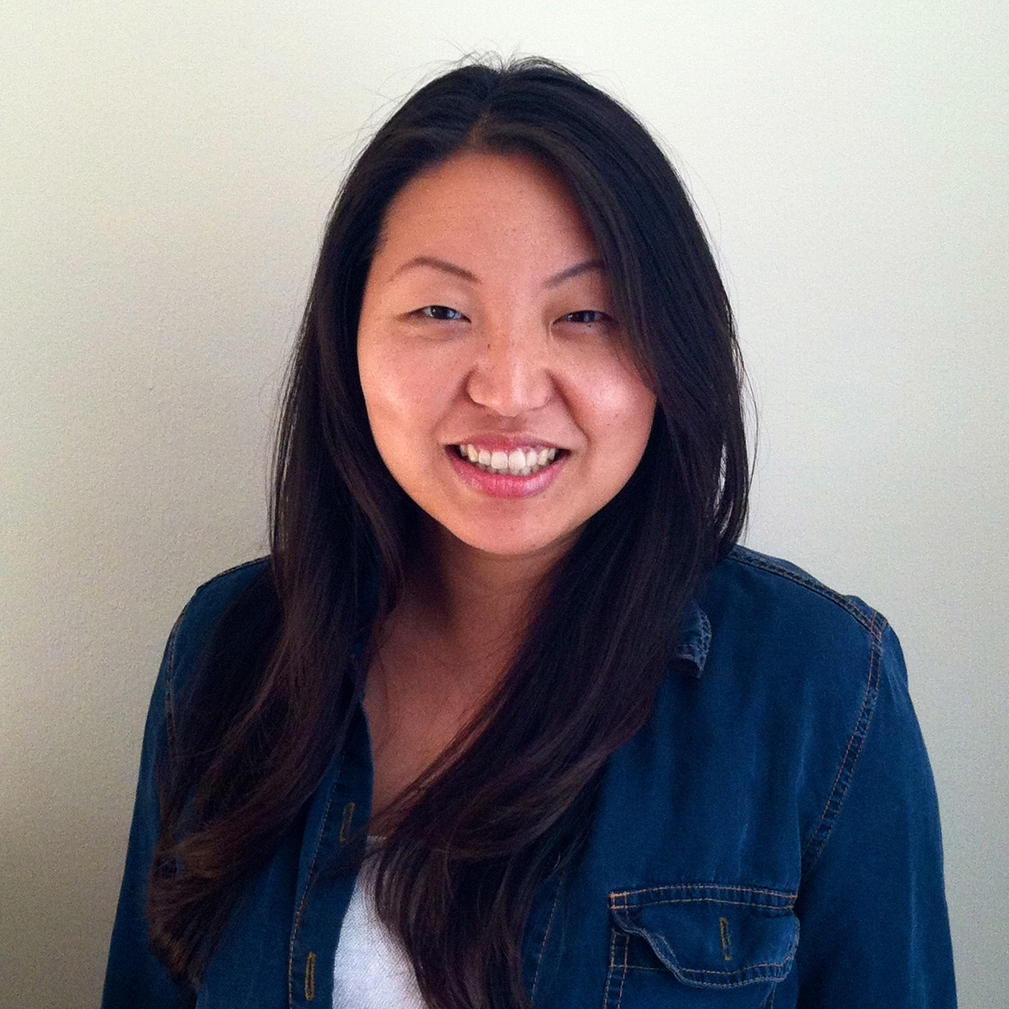
Combining her passion for business with her love of the arts, Gina brings to 1982 nearly a decade of experience in the entertainment industry, where her expertise in handling complex deals for A-list talent have made her an essential part of the finance team at WME. Prior to 1982, she produced a web series for AtomFilms, also written and directed by her husband and producing partner, Jeremy Breslau, and she is currently prepping his upcoming projects.

ROBERT LATHAM BROWN Co-Producer
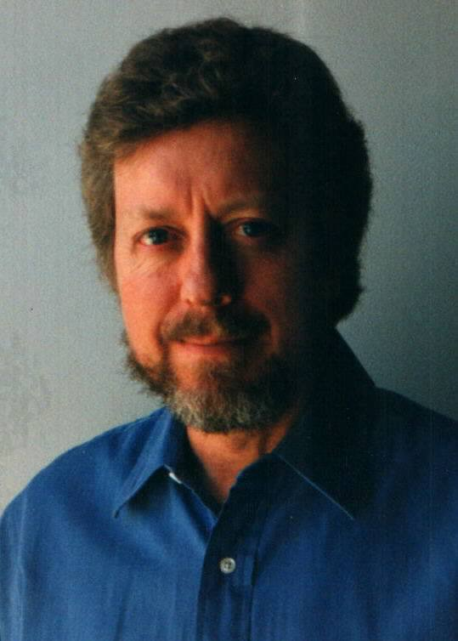
Robert has worked on over 40 films ranging in cost from $1.6 million to over $100 million as both a unit production manager and producer. In addition, he teaches Production Planning at USC, and is the author of Planning the Low-Budget Film, which was a finalist in the 2007 Ben Franklin Awards and a winner at the Hollywood Book Festival. Robert’s expertise in every aspect of production have made him indispensible to such diverse talents as Mel Brooks and Paul Verhoeven. His credits include The Blues Brothers, Return of the Jedi, Indiana Jones And The Temple Of Doom, Spaceballs, and Starship Troopers.

FRANK BUONO Cinematographer
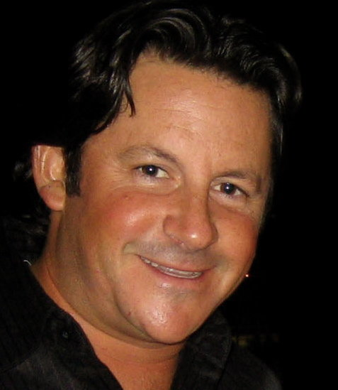
Honing his craft under numerous Oscar-winning cinematographers (Robert Elswit, Dean Semler, Emmanuel Lubezki, to name a few) as the most in-demand camera operator working today, Frank is making his transition to cinematographer on 1982. Prior to tackling this latest challenge, Frank distinguished himself with his brilliant work on the classic four minute one take ‘car sequence’ in Children of Men, which was honored by AMC as one of the best tracking shots of all time. His skills have made repeat customers of Steven Spielberg, Michael Bay, and Steven Soderbergh, who have found his ability to translate their vision to the screen indispensable.

PATRICK M SULLIVAN JR Production Designer
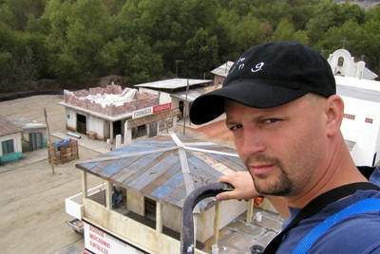
Patrick began as a set designer on Twister and Men in Black. Other notable visual achievements as set designer include The Game, Collateral, and What Women Want. Promoted to art director, he partnered with renowned production designer John Myhre on Wanted and Memoirs of a Geisha, the latter for which they won the Academy Award. He also served as sole art director on Clint Eastwood’s Oscar nominated Changeling, the supernatural drama Hereafter, and J. Edgar, and is the art director for Eastwood’s upcoming Jersey Boys. He recently wrapped Divergent, and won the Emmy for his art direction on Steven Soderbergh’s Behind the Candelabra.

THE CAST
Jakob Wedel (Young Zach)
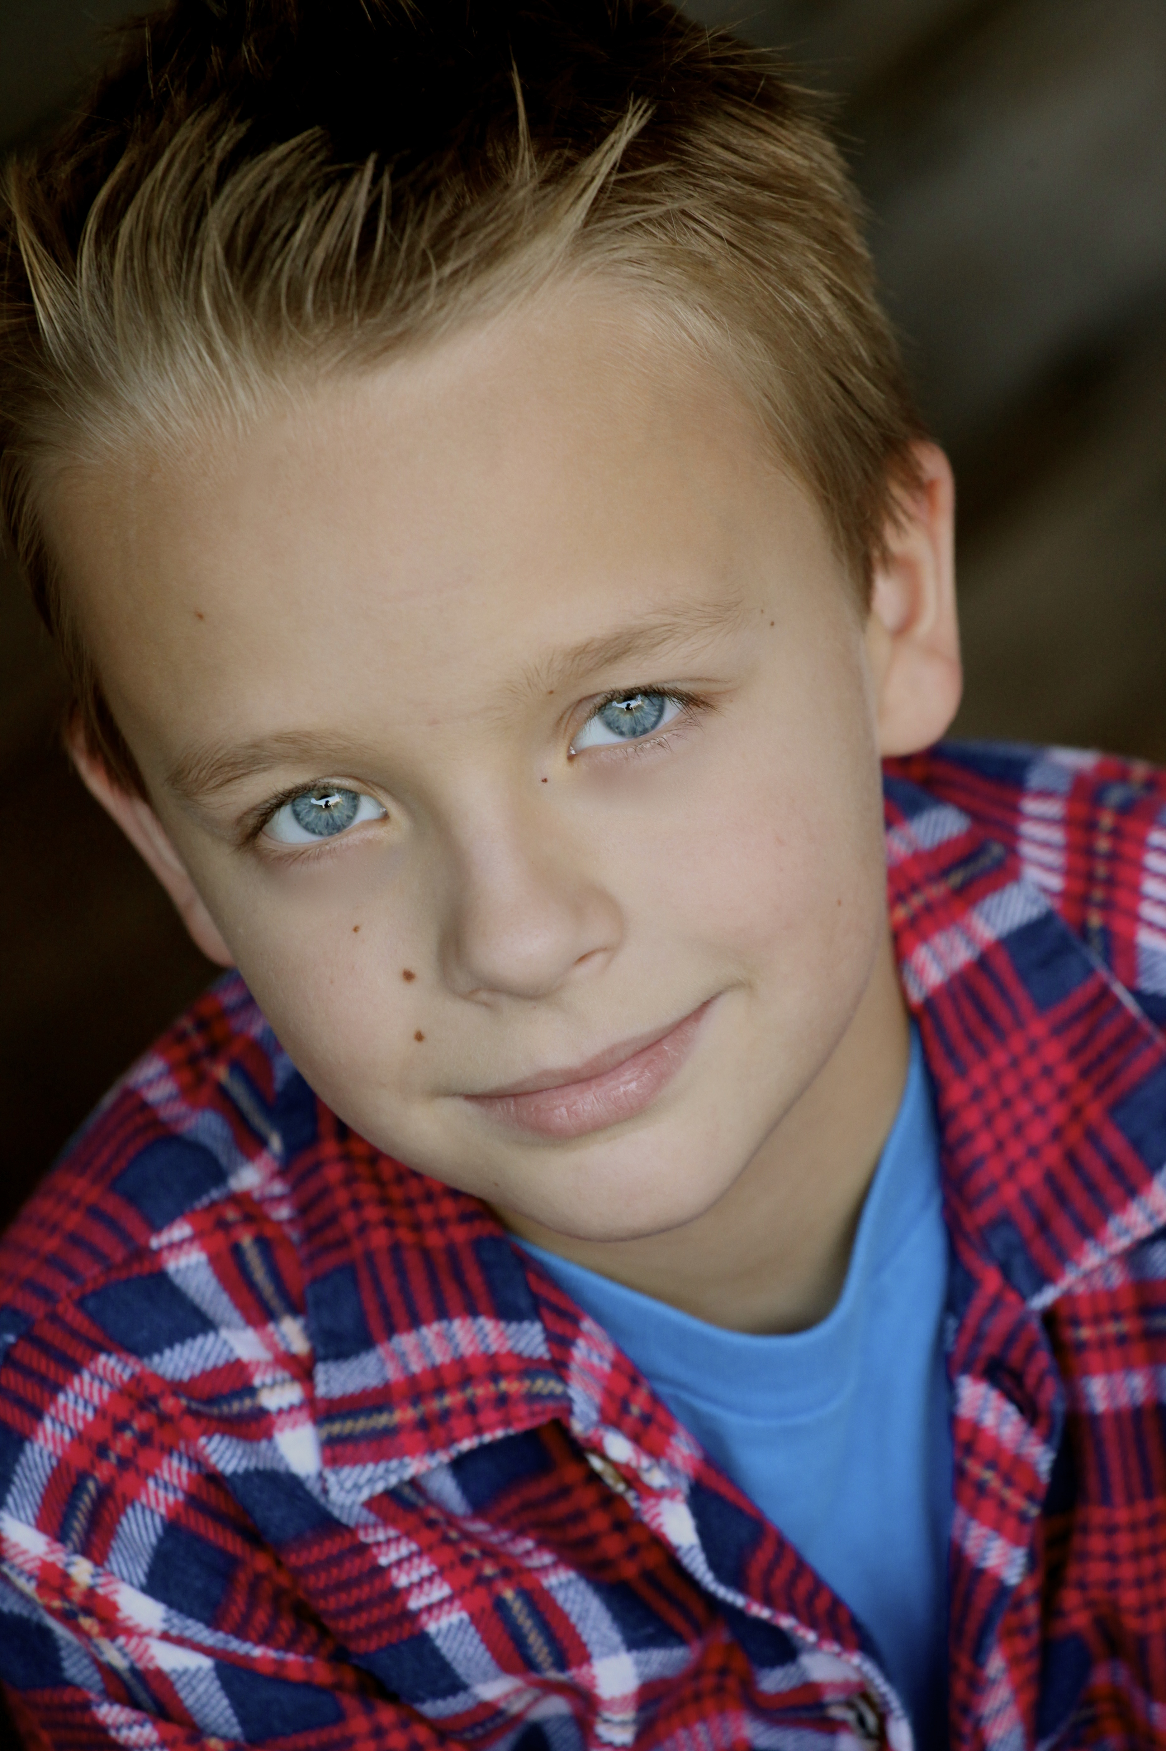
Jakob Wedel truly began acting the day he was born in Texas. He has done several short films, student films, commercials, and recently booked a co-star on TNT’s hit series Southland. Since being in LA he has started playing the guitar and piano. He has even written a few of his own songs. He has also taken an interest in writing scripts and hopes to be the next Ron Howard. He enjoys reading, swimming, horse back riding, and has a purple belt in Karate.

Kerry Knuppe (Melissa Baer)
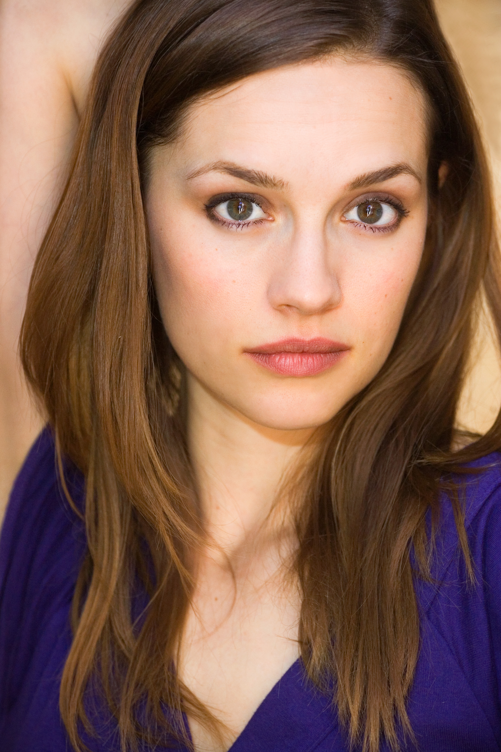
Kerry Knuppe began acting in Denver, starring in many theater and short film projects before eventually landing the lead role of "Lucy" in the successful independent comedy "Skills Like This." She can also be seen in other feature films including The Sensei, A Perfect Ending, Taking Capella and the thriller Home, alongside Heather Langencamp. She currently finished the role of Becca in Billy Ray Cyrus's latest film, Like a Country Song. Kerry now resides in LA and also works in TV, with roles of Marlene on CBS's Vegas and Jerica in ABC's Mistresses. She continues to improve her craft at the Actor's Studio in West Hollywood.

Kevin Michael Walsh (Craig Baer)
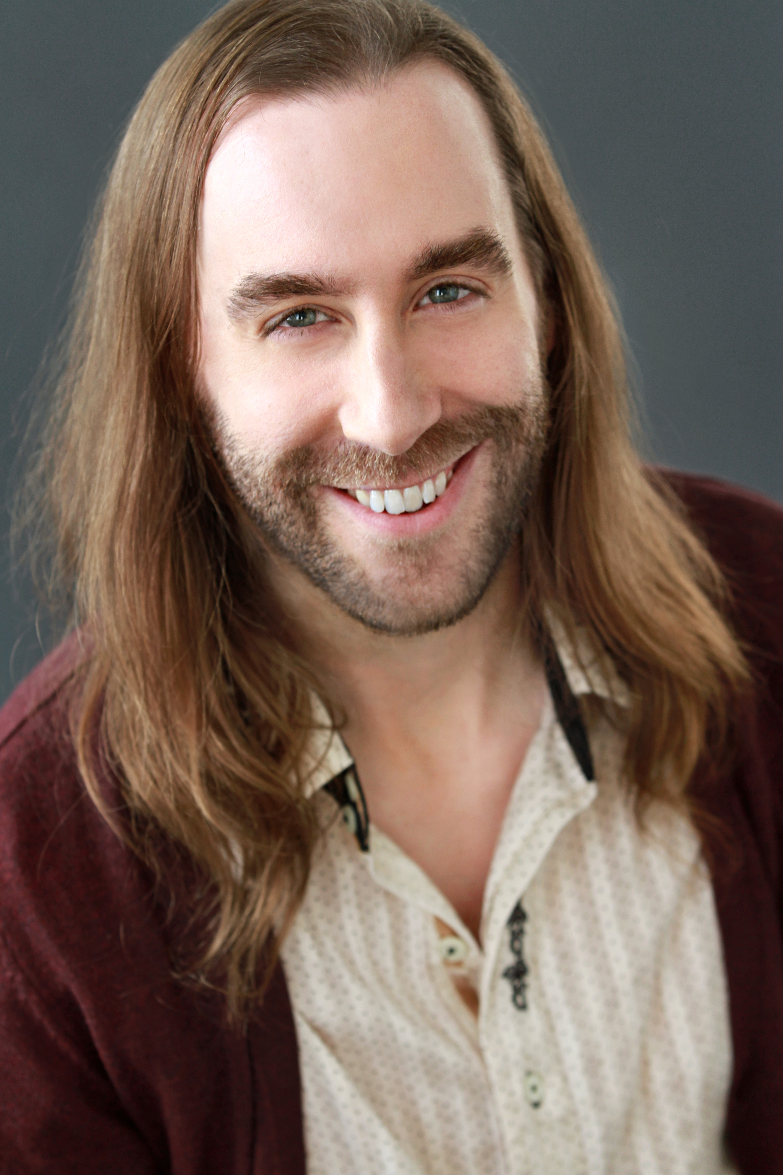
Kevin Michael Walsh began his acting career studying and training in his hometown of Cleveland, Ohio. Upon graduating he relocated to Los Angeles to pursue work in television and film. He has landed a string of roles in independent feature films including “Boys of Summerville”, “Decisions”, and “Tied Up”. Most recently Kevin made an appearance on an episode of “Justified”. He has also starred on shows such as “Southland”, “True Blood”, “Raising Hope”, “How I Met Your Mother”, “My Name is Earl”, and “King of Queens”, among others.

Terence Leclere (Zach Baer)
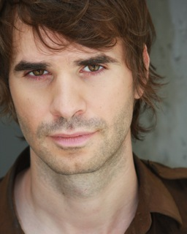
Terence Leclere is an LA based Actor and Singer/Songwriter. He was born in Paris, France, and grew up in NY, retaining his dual citizenship. He studied at the SUNY Purchase Acting Conservatory, Oberlin College and is a graduate of both William Esper studios and The Second City Conservatory in Los Angeles. Select credits include Bertolt Brecht's "A Man's A Man", "Guided Consideration..", "Silver Lake", "Hollywood Je T'Aime", "Land of the Lost", "Lymelife" and "Finding Emo". TL also performs comedy and music regularly (most notably his “Girl Songs”) earning residencies at various music and comedy venues in LA.

Helen Duffy (Grandma Rebecca)
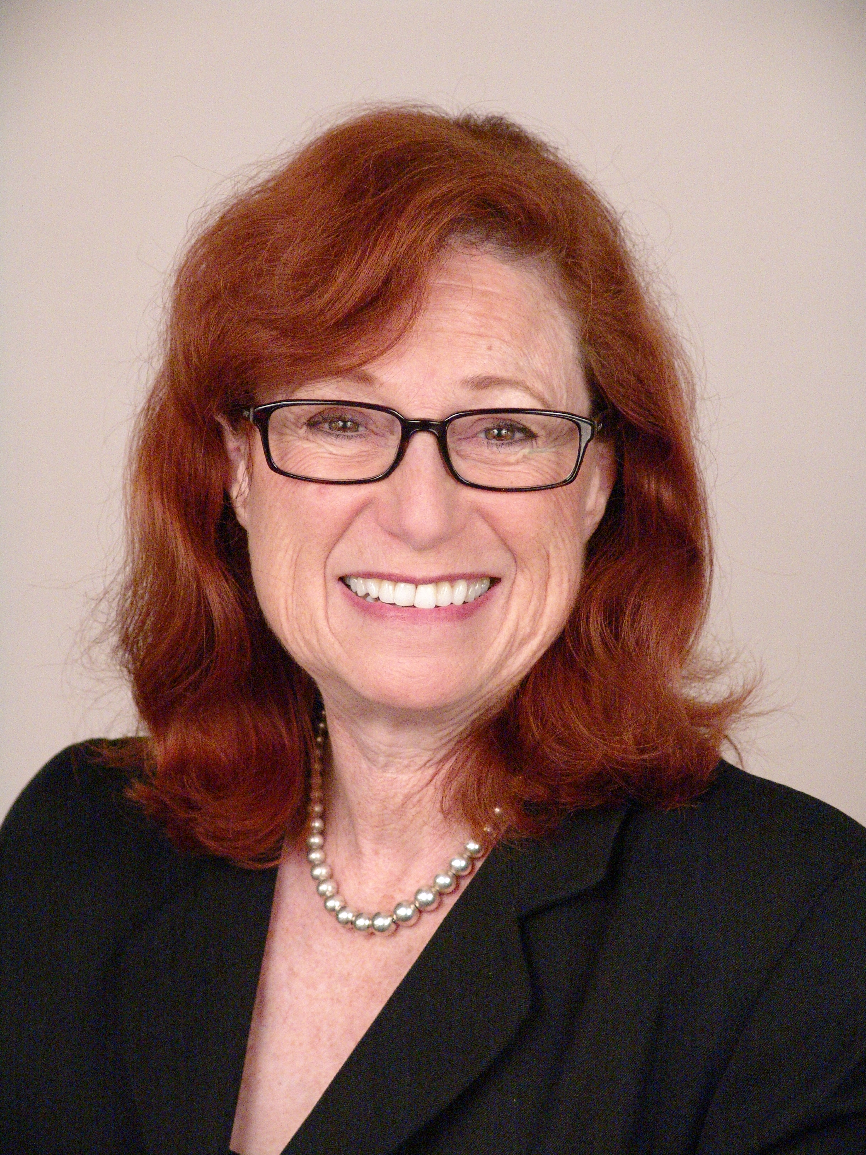
Helen Duffy began her career in NYC playing leading roles in plays by Shakespeare, Moliere, Strindberg, and Clifford Odettes at the award-winning Roundabout Theatre. Her many TV appearances include guest starring roles on the classic sitcoms, “Night Court”, “The Golden Girls”, “Who’s The Boss?”, and “Frasier” and the popular dramatic series, “The West Wing”, “LA Law”, “The Practice”, and “Ally McBeal”, and more recently on “The Unit” and “Hannah Montana”. Film credits include “Breakdown” with Kurt Tussell, “Terminator III” with Arnold Schwarzenegger, and “Austin Powers” with Mike Meyers. Helen serves on the Board of Directors of First Stage where she has directed and appeared in many plays, workshops, and staged readings.

PRODUCTION STILLS

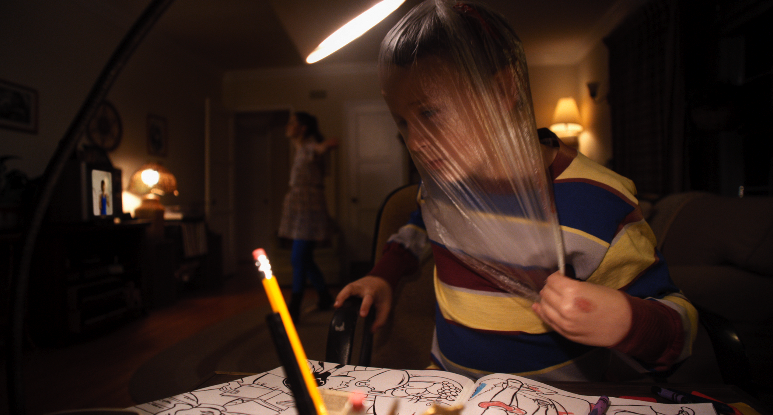

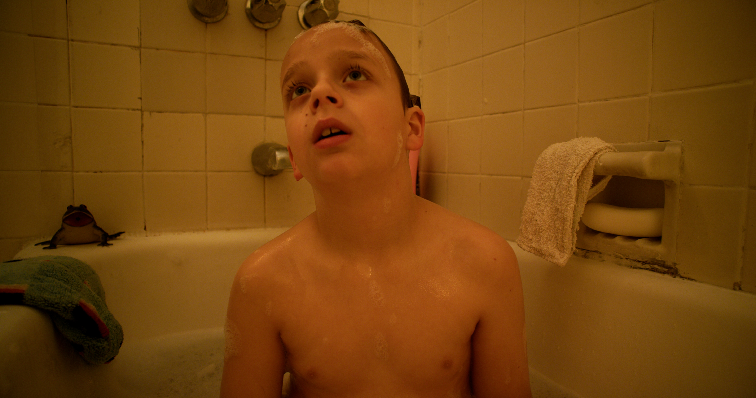

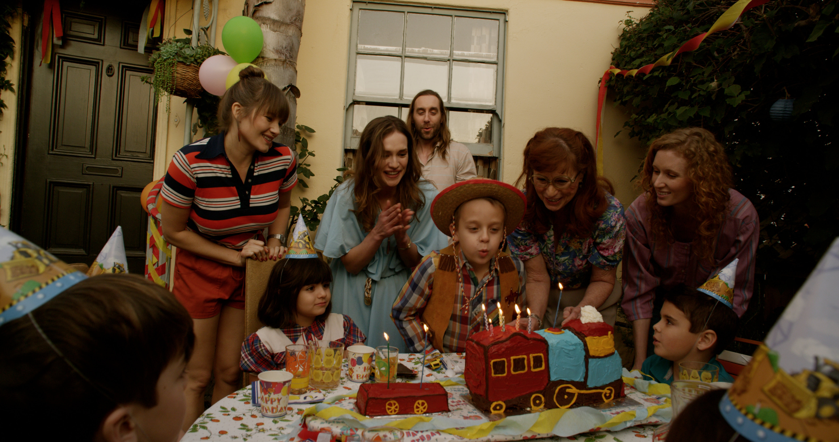

BEHIND THE SCENES

